6/22/2023

Javarn Jean Tromp de Haas

2021001030

ITWD7.358 Web Application Programming

Assessment 2

# Executive Summary:

My project of choice for assessment 2 is an online store named PureTech, which mainly focuses on selling anything technology related such as phones, laptops, and TVs. Main features of the website include a store page, where products are listed in a table format. These products can be clicked on to expand for more details, from which the user can add them to their shopping cart. After they’re happy with the products they’ve selected, the user then clicks the checkout button in their cart, leading them to complete the transaction through the checkout page. Another important feature of the website is the forum, which allows anyone with an account to post about any question or topic related to the store. Similarly, those with accounts can also reply to these forum posts.

The website will be built through the use of PHP for the functionality of the application, HTML for the header and footer which will remain universally the same across all pages, and CSS for additional styling of the elements. I’m also using XAMPP, which is a web server solution that provides the necessary technologies that are required for my application to function. This includes a MySQL database, where information such as products, users, and orders will be stored and managed.

# Functionality:

My final application and its functionality must meet the project requirements that have been outlined in the assessment guidelines. A user authentication system has been implemented. When first accessing the website, users will be able to freely browse the products and forums. If they wish to interact with these elements, however, they must create a free account through the accounts page.

On this accounts page, the user will be presented with two options: register or login. If the user has an account that already exists in the database, they can enter the login details to access it. If not however, they must create a new account containing information such as their name, email, and password. Note that email is a unique field, one email can only be used for one account. After logging in, the options on the accounts page have now changed. The user will be welcomed by their first name, information that has been stored with cookies. They will also be able to logout of their account, and also change their password.

Now that the user is logged in, they’re free to use the website without any limitations. On the store page, they can add as many items as they want to their cart and proceed with them through the checkout. They can also now post and comment on the forum page. If the account the user logged into is considered an admin account, they get other abilities on top of these standard user interactions. This mainly refers to the admin dashboard, which allows them to perform database actions such as add, retrieve, edit, and remove on main aspects such as users, products, and posts.

# Coding and Design:

**Wireframes:**

Prior to the beginning of development, I created some wireframes of a potential front-end for my website in draw.io.

**Authentication Feature:**

**Core Feature (Online shopping):**

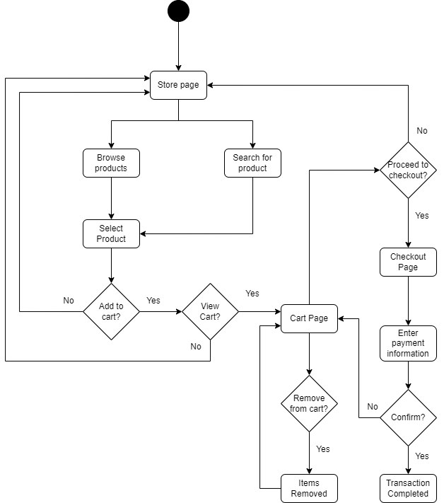

**Communication:**

**Database Design:**

